**AI Usage Declaration**

### **AI Usage Declaration Submission Instructions**

When completing your assignment, you must download and fill out the "AI Usage Declaration" form for each assignment where AI use is permitted. Once completed, convert the form to a PDF and **save it as aud.pdf**. Submit this PDF along with your assignment. This declaration is required to confirm your appropriate use of AI tools, and failure to submit it will result in a zero for the assignment. Ensure all information provided is accurate and aligns with the academic integrity guidelines.

**Student Information**

* Name: Leonardo Pereira
* Student ID: 101419551
* Course Code: COMP3123 – full stack

**Assessment Information**

* Assessment Name: Assignment 1
* Submission Date: October 13

**(Add * for those applicable)**

**AI Tool(s) Used:**

* *ChatGPT*
* Copilot
* DALL-E
* Other: [Specify]

#### **Purpose of AI Usage:**

(Select the primary purposes for which AI was used in this assessment)

* Idea Generation
* Writing Assistance
* Image Creation
* *Coding/Programming*
* Language Refinement
* Other: [Specify]

#### **Details of AI-Generated Content:**

(Provide brief examples or descriptions)

* **1:** How do I make a unique user ID like this: ah4BS4ur8sa4GMDG

Chatgpt answer: const randomPart = Math.random().toString(16).substring(2, 14); // Generate a random part

**2** – was having errors with thunderclient (postman) so I pasted my error, it told me to fix my routing which was the issue

http://localhost:3001/api/v1/emp/employees/7472dcc7c83f 404 Not Found <!DOCTYPE html> <html lang="en"> <head> <meta charset="utf-8"> <title>Error</title> </head> <body> <pre>Cannot GET /api/v1/emp/employees/7472dcc7c83f</pre> </body> </html>

ANSWER:

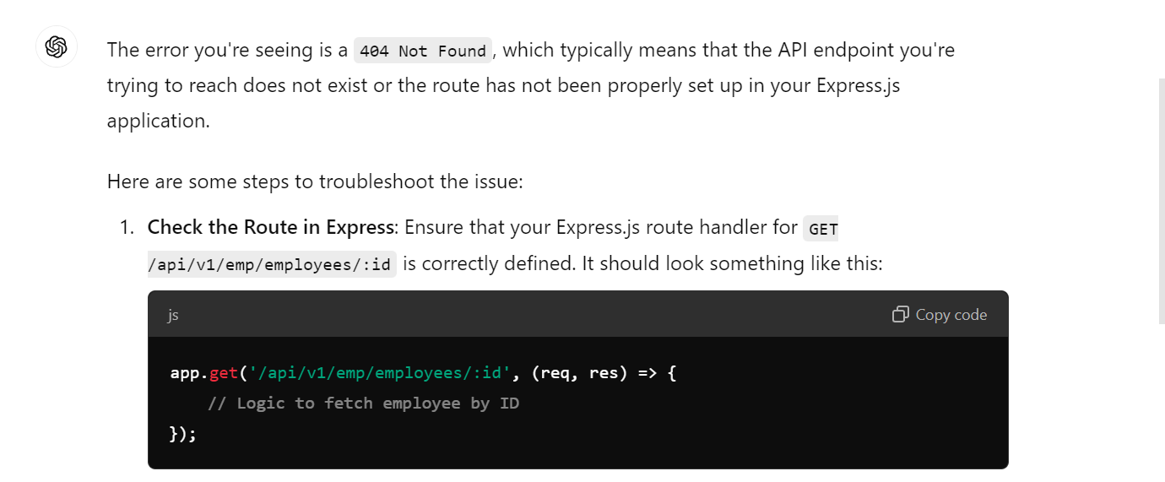

**3.** how can I check if a user exists within a mongo database

Response: told me to use .findOne and make functions async

I used to have this line     const userExists  = users.find(user => user.email === email);

It told me to switch to const userExists = await User.findOne({ email });

**4**. I added _id to my database schemas and I was having errors running,

Response

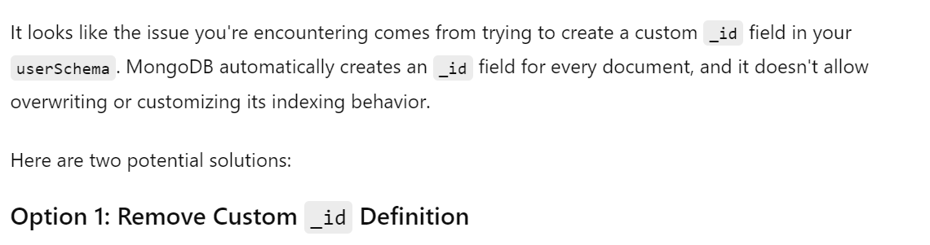

And so given the answer I removed this from the schema and it was fixed

**5**. My employees delete wasn’t working, I sent my error 404, the postman link and my code

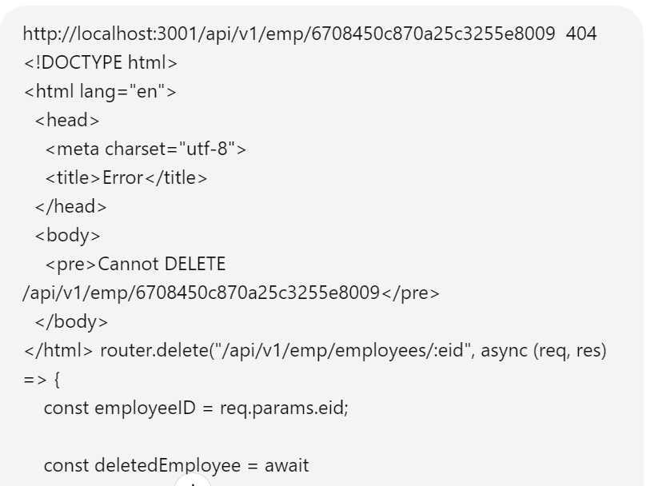

Answer:

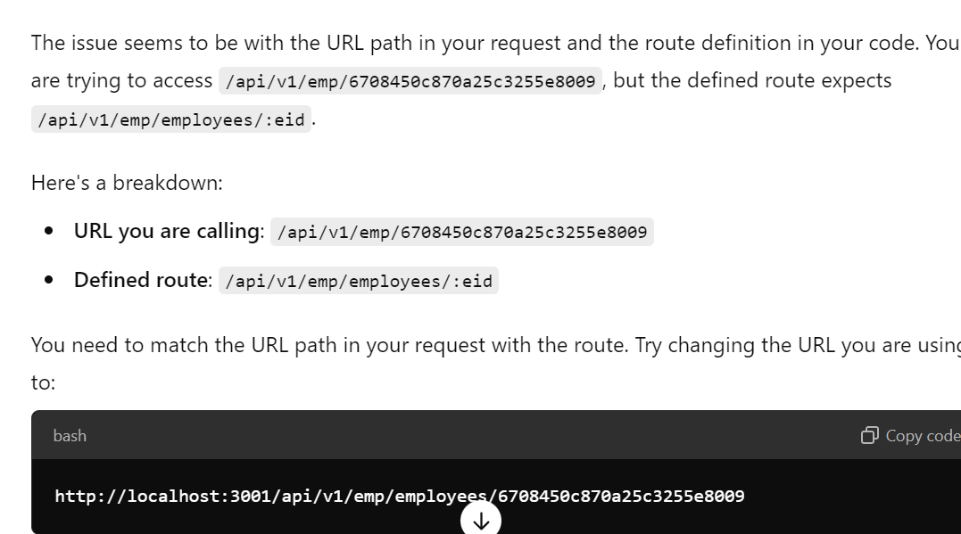

I ended up doing this and It worked, I had forgotten to add /employees to the postman

#### **Review and Refinement:**

(Select the actions taken to refine AI output)

* Edited AI-generated content for accuracy – **used other websites to check* - crossed check with node.js documentation**
* Cross-checked AI output with reliable sources - **used other websites to check* - crossed check with node.js documentation**
* Made significant changes to AI-generated text or images
* Other: [Specify] - **used other websites to check* - crossed check with node.js documentation**

#### **Quality Assurance and Ethical Considerations:**

(Briefly describe how you ensured the quality and ethical use of AI)

**Quality Check:** Check official documentation and guides on youtube and online and cross reference them

**Ethical Use:** I try not to use it to create major code for use, I use it for more annoying and minor things that I can’t seem to get working. I also mainly use it for bug fixing and syntax as in school I use a lot of different languages and forget some things and get others confused.

#### **Reflection on AI Usage:**

(Briefly reflect on your experience using AI)

**Reflection:** AI helped as reading the given file was giving me issues, AI is a quick solution, I asked, it gave me a fix, I then cross checked the information given to see and help. I think AI is a great way to help speed up things that might take longer without.

**AI Usage Declaration**

I, [**Leonardo Pereira**] [**101419551**], declare that the information provided in this AI Usage Declaration is accurate and truthful. I have adhered to the academic integrity guidelines and properly referenced all AI-generated content used in this assessment.

**Original Work Declaration**

* I declare that the work submitted is my own and that AI was used only as a tool to assist me in its completion.
* I understand that I am responsible for the content and quality of the work submitted, even if AI was used to generate parts of it.